SKÚŠANIE SLOVÍČOK
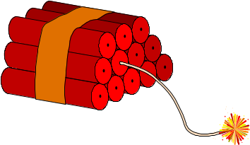
- Housing and Home – 5 October
- Human relations - 15 October
- Shopping and Services – 25 October
- Health Care – 5 November
- Travel – 15 November
- Education – 25 November
- Jobs and Professions – 5 December
- Human Relationships – 15 December
- Man and Nature – 5 January
- Science and Technology – 5 January
- Man and Society – 15 January
- Communication and its Forms – 25 January
- Mass Media – 5 February
- Young People and Their World – 15 February
- Food – 25 February
- Interests and Leisure – 28 February
- Multicultural Society – 5 March
- Towns and Places – 15 March
- Fashion – 25 March
- The Book- a Person´s Friend – 31 March
- Examples and Ideals – 5 April
- The Countries Whose Language I Am Learning – 10 April
- Slovakia - My Homeland – 15 April

Skúšanie maturitných tém

- Family I. – 15 September
- Family II. – 30 September
- Culture and the Arts – 10 October
- Sport – 17 October
- Housing 1 - my house 24 October
- Housing 2 – my town 7 November
- Shopping and Services – 14 November
- Health Care- 21 November
- Travel 28 November
- School and Study I - 28 November
-----------------------------------------------------------------------
- School and Study II - 16 January
- Human Relations - 13 February
- The Human Race and Nature 20 March
- Development of Science and Technology 3 April
- Man and Society - 10 April
- Jobs - 17 April

Maturitné témy – kontrola vypracovania

Family I. –
Family II. –
Culture and the Arts –
Sport –
Housing 1 - my house
-----------------------------------30 October
Housing 2 – my town
Shopping and Services
Health Care-
Travel
-----------------------------------30 November

Písomné práce - na odovzdanie - oktáva

Opis osoby, životopis - 13 September
Opis miesta - 4 October
Opis udalosti - 11 October
Príbeh – 18 October
Neformálny list - 8 November
Formálny list – žiadosť - 15 November
Formálny list – sťažnosť - 29 November
Referát - 11 December
Článok – 11 December
Recenzia - 20 December

